Engineering a better world: National Engineers Week

建设更美好的世界：国家工程师周

As we begin National Engineers week, which spans from February 18-24, 2018, we are more than ever aware that engineers make a difference in the world. Here are some examples:

当我们开始全国工程师周，时间跨度从二月18-24日，2018，我们比以往任何时候都更清楚，工程师在不同的世界。下面是一些例子：

NASA FINDER equipment locates trapped victims of the recent Mexico earthquake

美国宇航局探测器设备被困在最近的墨西哥地震中。

How NASA technology helps in natural disasters

NASA技术对自然灾害的帮助

Hurricane hardening for utility power architectures: Puerto Rico

实用电源架构强化飓风：波多黎各

How NASA helps Earth in natural disasters

美国航空航天局如何帮助地球应对自然灾害

We, as engineers, need to spread the word that the world needs more of us. We need to go to children, teens, educators, parents and especially tap women and young girls and encourage them to pursue careers in science, math, and engineering (STEM) at a minimum, which could lead to engineering.

作为工程师，我们需要传播世界需要我们更多的话语。我们需要去儿童，青少年，教育工作者，家长，特别是挖掘妇女和年轻女孩，并鼓励他们从事科学，数学和工程（STEM）在最低限度的工作，这可能导致工程。

Engineers are a rare breed, dont let us be the last Jedi of the technical world.

工程师是一个罕见的品种，也T让我们成为的技术世界最后的绝地。

Want to be part of the technology to bring astronauts to Mars?

想成为将宇航员带到Mars的技术的一部分吗？

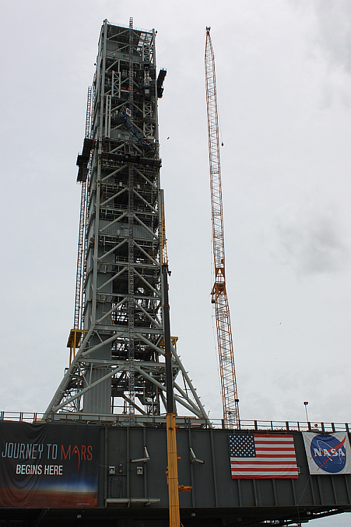

图1: Lets get young people excited about what they can do in their future. The astronauts going to Mars and the scientists that will enable that effort are in grammar school and high school right now.

图1: 让让年轻人兴奋，他们可以在自己的未来。去Mars的宇航员和将使这一努力得以实现的科学家现在在文法学校和高中。

Contact the local science and math faculty at your nearby schools and find out how you can help foster STEM. We can be mentors, tutors, as well as give presentations regarding STEM. Lets show them what mathematics and science can do---let it be fun and exciting for them.

在附近的学校联系当地的科学和数学教师，找出如何帮助培养学生的能力。我们可以做导师、导师，也可以做关于STEM的演讲。让表明他们的数学和科学能做的---让它成为他们的乐趣和令人兴奋的。

We can participate in local or regional competitions such as FIRST robotics or MATHCOUNTS.

我们可以参加当地或地区的比赛如第一机器人或数学。

Personally, I like to visit local university Robotics clubs like Arizona State University Rossum Rumblers---there are such creative young people enjoying such activities right in your own area.

就我个人而言，我喜欢去当地的大学机器人俱乐部像亚利桑那州国家大学Rossum rumblers ---有创意的年轻人享受这样的活动，就在自己的领域。

Share with us some of your ideas regarding this topic in the comments below by registering on Planet Analog.

请在下面的评论中与我们分享一些关于这个主题的想法。